Operational Concept Description (OCD)

Arts & Crafts Website

04

Lauren Mermel – Operation Concept Engineer
Abhishek Chauhan – Life Cycle Planner
Sukriti Jain – System Architect
Roopa Dharap – Project Manager
Harsha Medikonda – Feasibility Analyst
Kelvin Zhu - Verification and Validation

Version History
Date | Author | Version | Changes made | Rationale
09/26/12 | LM | 1.0 | - Sections 1, 2, 3.1 | - Initial draft
10/13/12 | LM | 2.0 | - Added sections 3.2 and 3.3  - Modified Program Model  - Modified Benefits Chain Diagram  - Modified System Boundary Diagram  - Modified section 1.2  - Modified section 2.2 | - We completed our remaining win-win sessions and therefore had enough information to complete the remaining sections.  - Program Model and Benefits Chain diagram needed to be modified to correctly represent changing client values, and removal of product testers as stakeholders.  - System Boundary Diagram changed as we decided on a different infrastructure.
10/24/12 | LM | 2.1 | - Modified Sections 1.1 and 3.2.1 | - Bug fixes from FC evaluation.
10/28/12 | LM | 2.2 | - Modified Shared Vision  - Modified Benefits chain  - Modified Element Relationship Diagram  - Modified System Boundary and Environment Diagram.  - Modified Section 3.2.5  - Modified Section 3.2.2  - Modified Section 3.3.2 | - Updated vision from client  - Fixes post Core FC grading  - Modifications to include WordPress as an additional service to be included.
11/2/12 | LM | 2.3 | - Modified Benefits Chain  - Modified System Boundary and Environment Diagram  - Modified Levels of Service | - Corrections take into account feedback from ARB session.
11/12/12 | LM | 2.4 | - Modified Status of OCD  - Added 3 business case figures | - Corrections from response to FC package.
11/25/12 | LM | 3.0 | - Modified section 1.2  - Modified System Boundary and Environment Diagram  - Modified Business Workflow Diagram | - Requirements change has shifted development plan.
12/16/12 | KZ | 3.1 | - Minor fix to a table number | - Fixing a minor typo

Table of Contents
Operational Concept Description (OCD) i
Version History ii
Table of Contents iii
Table of Tables iiv
Table of Figures v
1. Introduction 1
1.1 Purpose of the OCD 1
1.2 Status of the OCD 1
2. Shared Vision 2
2.1 Benefits Chain 3
2.2 System Capability Description 3
2.3 System Boundary and Environment Error! Bookmark not defined.
3. System Transformation 5
3.1 Information on Current System 5
3.2 System Objectives, Constraints and Priorities 5
3.3 Proposed New Operational Concept 8
3.4 Organizational and Operational Implications 10

Table of Tables
Table 1: The Program Model 2
Table 2: Capability Goals 5
Table 3: Level of Service Goals 6
Table 4: Relation to Current System 7

Table of Figures
Figure 1: Benefits Chain Diagram of Arts & Crafts Website 3
Figure 2: System Boundary and Environment Diagram of Arts & Crafts Website 4
Figure 3: Element Relationship Diagram of Arts & Crafts Website 8
Figure 4: Business Workflow Diagram of Arts & Crafts Website (Customer) 9

Introduction

Purpose of the OCD

This document provides, in detail, the shared visions and goals of the stakeholders of the Arts & Crafts Website for client Amy Hvitfeldtsen. The success-critical stakeholders of the project are Amy Hvitfeldtsen, as the client, and project owner; charities, that will profit from this project; customers, who will use this website as a vehicle to purchase products; a graphic designer, who will design the layout and look; and the developers, the CS577A students listed above.

Status of the OCD
The status of the OCD is version number 3.0. This is the third version of this document, and all sections have been completed. Many sections have also been modified as the result of a large requirements change. As a result the support infrastructure and development plan has changed significantly. These changes can be seen in red throughout the OCD. Additionally some of the original deliverables have been eliminated to accommodate the timeline and newer, more desirable requirements. The content should be considered as final for the purposes of this project.

Shared Vision
Supporting children with special needs through an arts and crafts website that creates a fulfilling experience for both the crafter and the consumer.

Table 1: The Program Model
Assumptions

- People are interested in arts and crafts
- There will be materials available
- People find the activity easy and fun to do
- People want to give to charity

Stakeholders | Initiatives | Value Propositions | Beneficiaries
- Developers  - IV/V  - Amy (Client)  - Graphic Designer  - Charities  - Customers  - Attorney | - Develop Arts & Crafts website  - Finalize product details  - Generate graphics (design that makes the charitable purpose evident).  - Use word of Mouth  - blog/chat (interactive features to increase community interest).  - Finalize cash flow | - Increase Sales  - Attract charity enthusiasts, craft enthusiasts and families.  - Make the site accessible to all/easy to navigate  - Increase awareness about the cause | - Charities (5P)  - Client  - Charity Enthusiasts  - Craft Enthusiasts

Benefits Chain

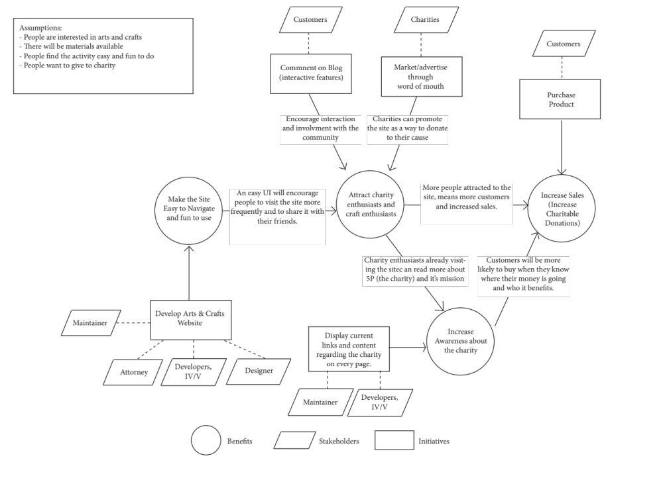
Figure 1: Benefits Chain Diagram of Arts & Crafts Website

System Capability Description
The system to be built is a merchant website targeted at craft and charity enthusiasts. The website will allow for secure payment, a blog, product views, shipping calculator, as well as interactive features like chat, or testimonials. Currently the client does not have a vehicle to sell the ornaments she crafts, the website would allow her to sell them and donate a portion of the proceeds to charity. According to the client there is a huge move towards social entrepreneurship, the idea that people respond well to companies that are giving something back.
Large craft stores like Michael’s could be seen as a competitor as they offer crafted ornaments for purchase online. However the client’s product differs in the fact that there is a personable, charitable aspect to her products, and a very targeted audience of crafters, families, and charity enthusiasts. Michael’s also does not provide the customer with the option to donate to charity, nor does it offer a blog, or chance to personally communicate with the product fabricator.

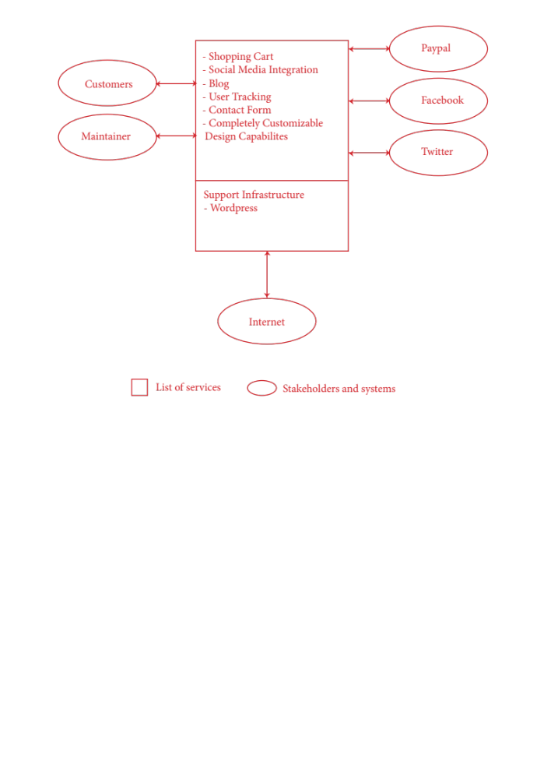
System Boundary and Environment

Figure 2: System Boundary and Environment Diagram of Arts & Crafts Website

System Transformation

Information on Current System

Infrastructure
Currently there is no infrastructure at the client’s organization. The client uses a MacBook for emailing and financial reports.

Artifacts
Currently there are no artifacts.

Current Business Workflow
As even the product has yet to be created and finalized, there is not a current business workflow.

System Objectives, Constraints and Priorities

Capability Goals
Table 2: Capability Goals

Capability Goals | Priority Level
OC-1 Purchase Product: The system is capable of allowing a customer to select and purchase a product. | Must have
OC-2 Blog: The system is capable of allowing the admin to submit and update blog posts. | Must have
OC-3 Shopping Cart: The system is capable of allowing the user to add and subtract items for purchase from his/her shopping cart | Must have
OC-4 Product Add/Remove: The system is capable of allowing an admin to add, remove, and update products for purchase | Must have
OC-5 Charity Presence: The system is capable of displaying content about the client’s charity | Must have
OC-6 Product Details: The system is capable of allowing a user to see a zoomed-in image of a product, and read product information such as materials, dimensions, price, and shipping. | Must have
OC-7 Social Media: The system is capable of social media integration through the presence of a “like us on Facebook” and “follow us on twitter” buttons. | Must have
OC-8 Traffic: The system is linked to an analytics service so an admin can track traffic. | Should have
OC-9 Site-Navigation: This system should be easy to use and navigate through. | Must have
OC-10 Contact Form: This system should allow customers to send emails to the admin through a form. | Could have
OC-11 Maintainability: The system should be simple enough for the client to maintain without additional assistance. | Should have

Level of Service Goals
Table 3: Level of Service Goals
Level of Service Goals | Priority Level | Referred WinWin Agreements
LOS-1 Browser Compatibility: This system should be compatible with the Safari (versions 5.2+), Chrome (versions 22+), Firefox (versions 15.0+), and Internet Explorer (versions 9.0+). | Must have | Win-Condition 1291
LOS-2 Mobile Compatibility: This system should be viewable on mobile devices. | Could have | Win-Condition 1291
LOS-3 Downtime: This system should be down no more than 8hrs/monthly (excluding natural disasters) | Should have | Win-Condition 1292
LOS-4 Page Load Time: The system should load pages quickly (no more than 8 second loads for image-rich pages). | Must have | Win-Condition 1286

Organizational Goals
OG-1: Increase sales and charitable donations.
OG-2: Increase awareness about the charity 5P.
OG-3: Attract craft enthusiasts.
OG-4: Attract charity enthusiasts and families.
OG-5: Make the site fun and easy to use, and accessible to all.

Constraints

CO-1: Budget: The new system must cost no more than $5,000.
CO-2: Deadline: The site needs to be up and running in time for Christmas sales.

Relation to Current System
As of now there is no current system, and thus nothing to compare to.
Table 4: Relation to Current System
Capabilities | Current System | New System
Roles and Responsibilities | N/A | Client will need to maintain website, blog and available products, ship each purchased item to customers, and distribute end of year checks to charities.
User Interactions | N/A | Users can purchase products and donate to a charity. Users may also comment on blog posts and leave testimonials.
Infrastructure | N/A | Wordpress
Stakeholder Essentials and Amenities | N/A | Must have a secure payment system through which users can purchase ornaments.
Future Capabilities | N/A | Site will allow for multiple users to sell crafts and designate a charity for a portion of their profits to go to.

Proposed New Operational Concept

Element Relationship Diagram
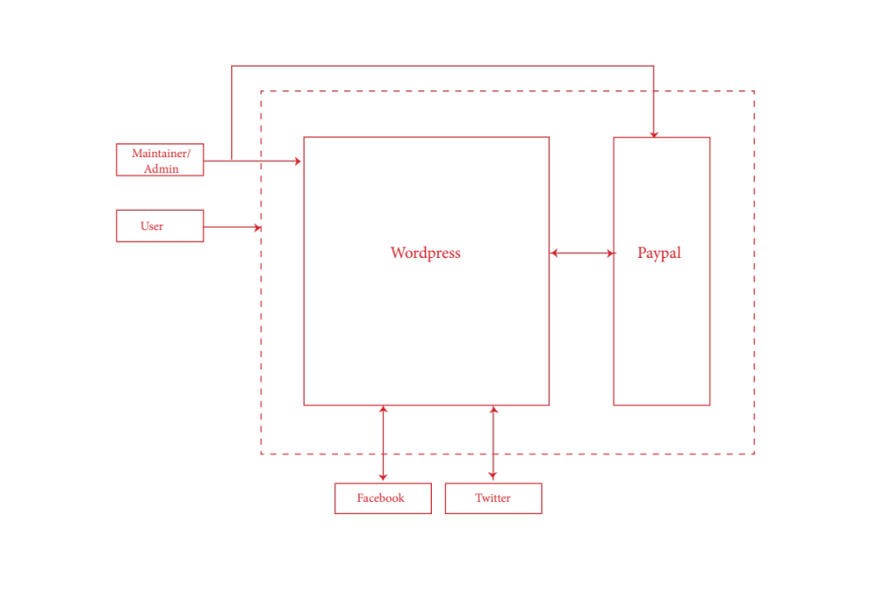
Figure 3: Element Relationship Diagram of Arts & Crafts Website
(Single NDI project)

Business Workflows
As there was not an existing system, please note that the business workflow, and system capabilities are all new.
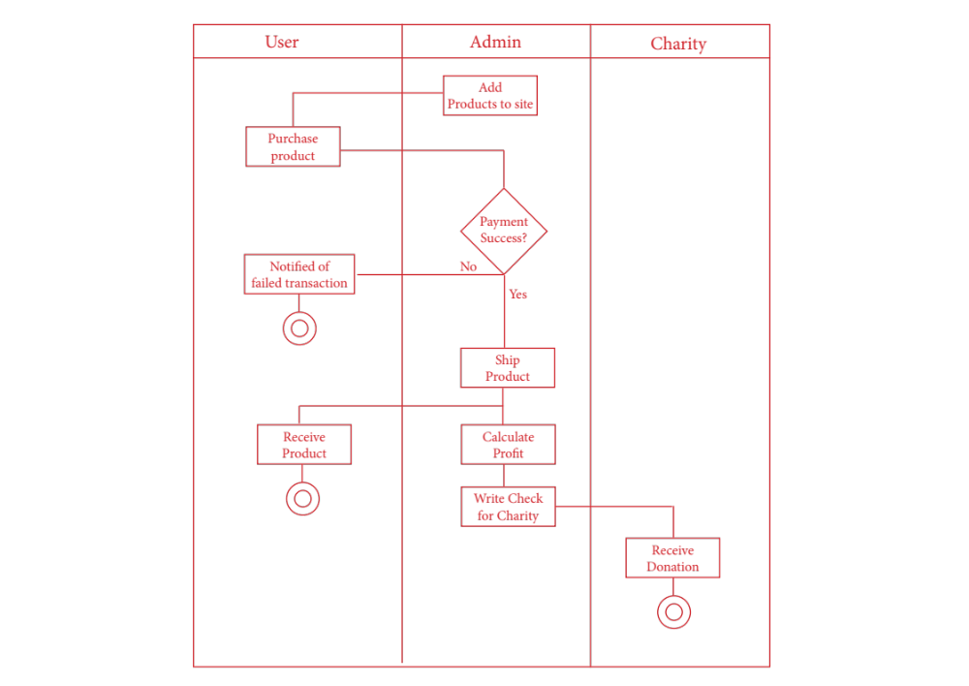

Figure 4: Business Workflow Diagram for Arts & Crafts website

Organizational and Operational Implications

Organizational Transformations
- The need for the client to maintain the website.
- The need for the client to develop her product and product line.
- The need for an attorney to review how a portion of the proceeds will be donated

Operational Transformations
There will be no operational changes, as currently there is neither a product nor any sort of system in place. All operational systems will be new and listed as follows:

- Having a secure payment process through which customers can purchase the product (ornaments).
- The option for customers to reach out to the client on social media, like Facebook and Twitter.
- Having a means of selling the ornaments online directly from the client, where national customers can access them.
- Having a blog to connect with families of children with special needs.
- Providing a vehicle to share information about the charity 5P.
- Having a means to accept donations (through product purchase) for charities.

